What are Wordpress themes

What are themes in Wordpress, what can the be used for, how to find them and install them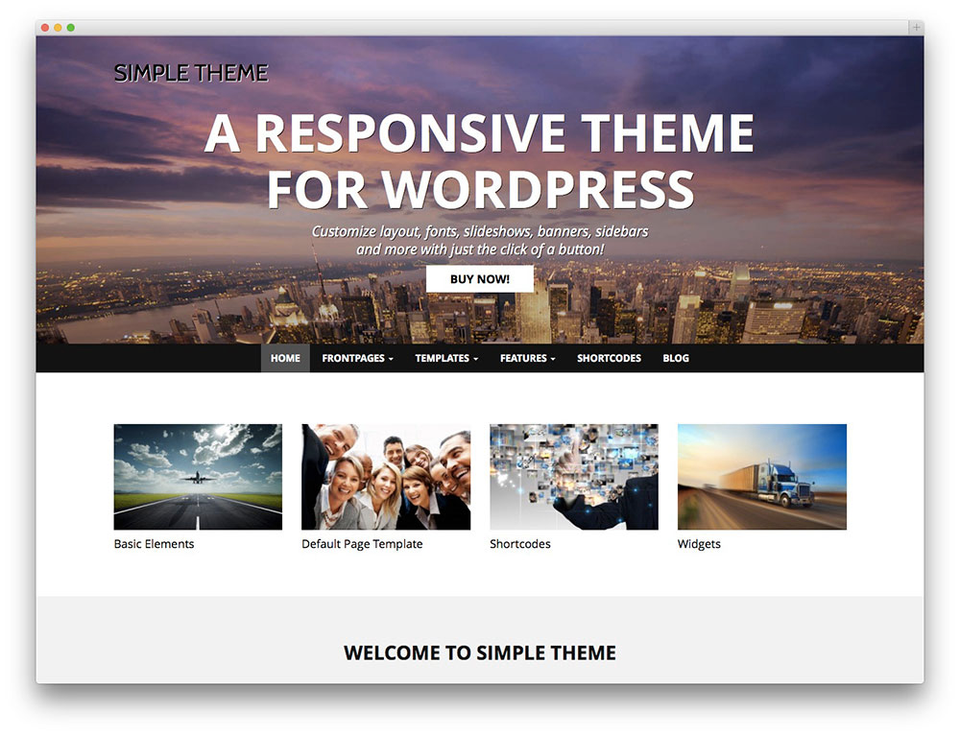

## Prepare a presentation

You will have to prepare a presentation (media of your choice) where you answer the following questions about Wordpress themes.

What are themes in Wordpress?

How do you find a theme?

How do you install a theme?

How do you change the name and description of a theme?

How do you change the screenshot image?

[Optional] What are child themes?

You are free to use any resource you see fit.

The following are just suggestions to get you started:

<https://developer.wordpress.org/themes/getting-started/what-is-a-theme/>

<https://www.youtube.com/watch?v=21It5oDzYZw> (first 5 minutes)

<https://wordpress.org/themes/>

<http://themeforest.net/popular_item/by_category?category=wordpress/&gclid=CMeB3dyS9MsCFUL2cgodH-INqg>

<http://www.elegantthemes.com/>